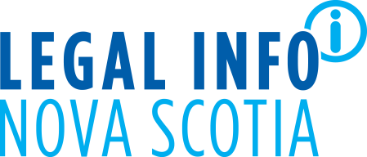

www.legalinfo.org

You are invited to attend the virtual 2026 Annual General Meeting of the Legal Information Society of Nova Scotia on June 24, 2026 at 4:45 pm. Join the AGM Zoom Meeting at: https://us06web.zoom.us/j/86950865689?pwd=yDQqtnQpOgdNDSKbD5I7K58N58NDmz.1

LISNS, with a core budget of $563,000, has helped Nova Scotians save more than $2.2 million since 2019 by offering accessible, user-friendly tools that produce legally valid documents. This continued success is reflected in the $1.2 million savings achieved April 2025 to March 2026 since the launch of the highly anticipated Enduring Power of Attorney App and Separation Agreement Maker App along with free notary clinics.

More than half of adult Nova Scotians do not have estate documents in place. These tools expand the range of legal needs that can be addressed affordably and efficiently, ensuring that more people have access to critical legal protections and planning resources at key moments in their lives.

The generosity of our anonymous donor and all donors directly supported our delivery of high-quality programs and services to help people with their many legal information needs this past year.

The AGM materials include:
❖ Agenda and 2025 AGM Minutes;
❖ Proposed slate of Directors;
❖ Annual Report 2025-26; and
❖ Draft Audited Financial Statements for Fiscal Year April 1, 2025 to March 31, 2026.
Thank you for your continuing support of LISNS activities. Together we are helping empower Nova Scotians to identify, prevent and solve legal issues.
Heather de Berdt Romilly, B.Comm, LL.B., LL.M.
Executive Director, LISNS

